Find the difference between the total number of **CITY** entries in the table and the number of distinct **CITY** entries in the table.  
The **STATION** table is described as follows:

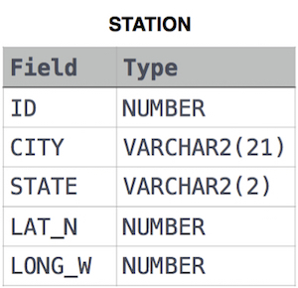

where **LAT_N** is the northern latitude and **LONG_W** is the western longitude.

For example, if there are three records in the table with **CITY** values 'New York', 'New York', 'Bengalaru', there are 2 different city names: 'New York' and 'Bengalaru'. The query returns , because .

Ans:

select count(CITY) - count(distinct(CITY)) from STATION;